1. **What is JavaScript and its role in Wed Development?**

JavaScript is a popular Programming Language that it is used for client side scripting language.

JavaScript is used to build web applications, mobile applications.

JavaScript is used to run by the browser not by the server.

JavaScript is used to build fast and responsive applications.

JavaScript file should be saved with .js extention.

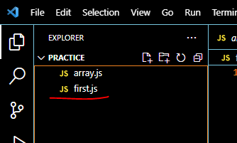

JavaScript should be be placed in between

<script>-----------javascript code------------</script> tags.

We can add JavaScript file any where in the HTML document.

<!DOCTYPE html>

<html lang="en">

<head>

    <meta charset="UTF-8">

    <meta name="viewport" content="width=device-width, initial-scale=1.0">

    <title>Document</title>

</head>

<body>

    <script lang="javascript" type="text/javascript">

        let a = 10;

        let b = 20;

    </script>

</body>

</html>

We can also place external .js source in the html document.

<!DOCTYPE html>

<html lang="en">

<head>

    <meta charset="UTF-8">

    <meta name="viewport" content="width=device-width, initial-scale=1.0">

    <title>Document</title>

    <script src="array.js" lang="javascript" type="text/javascript"></script>

</head>

<body>

    <h3>Adding .JS source file</h3>

</body>

</html>

JAVASCRIPT allows users to create dynamic and reactive web pages